

SIMATS ENGINEERING

Saveetha Institute of Medical and Technical Sciences
Chennai- 602105

Student Name: P Surya prakash Yadav
Reg. No: 192424396
Course Code: DSA0423 Slot: D
Course Name: Fundamental of data science for NLP
Project Title: Tourism Seasonal Trend Analysis Using Linear Regression And k- Means Clustering
Module photography’s : Activity Diagram
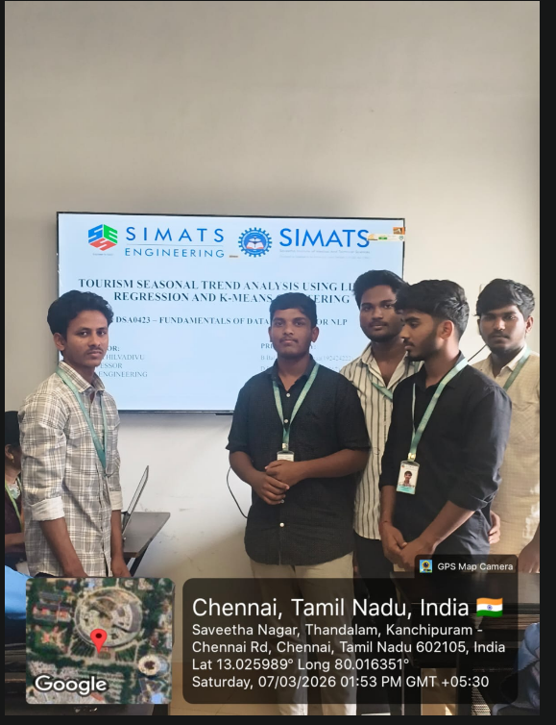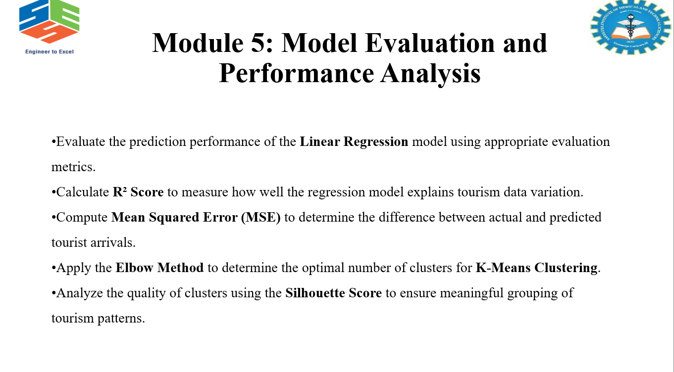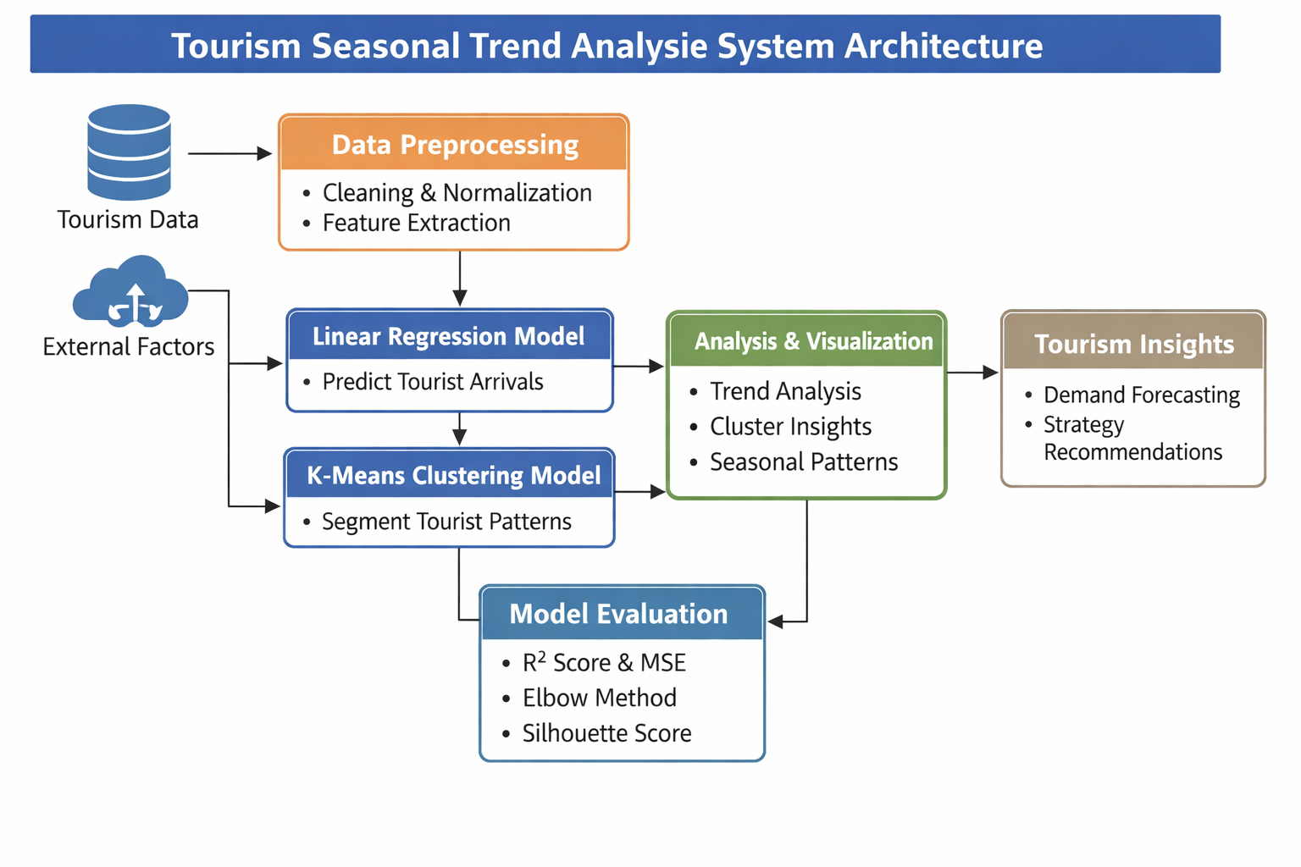

Project Description:
This project focuses on analyzing and predicting tourism patterns by identifying seasonal trends and grouping tourist behavior using data-driven techniques. The system utilizes historical tourism data such as visitor counts, seasonal variations, weather conditions, and travel trends to generate meaningful insights.
The project begins with data collection and preprocessing, where raw tourism datasets are cleaned, formatted, and missing values are handled to ensure accuracy. After preprocessing, Linear Regression is applied to model and predict future tourism trends based on historical data. This helps in understanding how tourist inflow changes over time and across different seasons.In addition, K-Means Clustering is used to segment tourism data into distinct groups based on similarities such as peak seasons, tourist preferences, and travel patterns. This clustering helps in identifying high-demand periods, low-season trends, and different tourist categories. The system also includes data visualization techniques to represent trends through graphs and charts, making the analysis easy to interpret. Finally, model evaluation metrics such as R² score, Mean Squared Error (MSE), Elbow Method, and Silhouette Score are used to measure the performance of the models.

Signature of student Guidance signature

